1. VPC

AWS Virtual Private Cloud (VPC) is a logically isolated network within the AWS Cloud. It allows users to define and configure their own virtual networking environment, including IP address ranges, subnets, route tables, and gateways. VPCs provide a private cloud-like experience within the public AWS cloud, allowing for greater control and security over AWS resources.

1. Internet Gateway

An Internet Gateway (IGW) is an AWS component that provides a path for network traffic to travel between a Virtual Private Cloud (VPC) and the public internet.

1. Subnet

A *subnet* is a range of IP addresses in your VPC. You can create AWS resources, such as EC2 instances, in specific subnets.

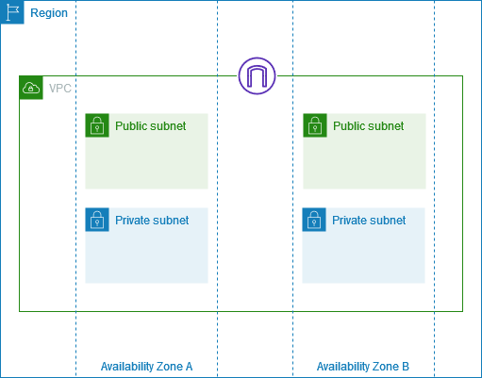

1. Route Table

A *route table* contains a set of rules, called *routes*, that determine where network traffic from your subnet or gateway is directed.

1. Security Groups

They act as virtual firewalls, controlling inbound and outbound traffic for resources within a VPC. They filter traffic based on rules, allowing or denying requests based on parameters like IP protocol, port number, and source/destination IP address or CIDR block.

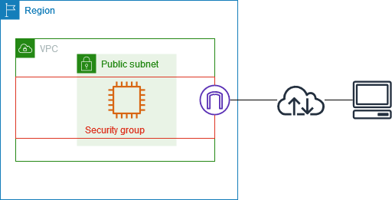

1. Key Pair

key pair is a pair of cryptographic keys, a public key and a private key, used for secure access to resources like EC2 instances. The public key is stored on the resource (e.g., EC2 instance), and the private key is kept by the user.

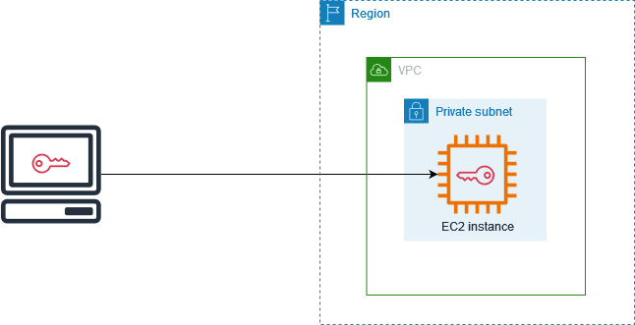

1. EC2 Instance

EC2 instance in AWS is a virtual server you can launch in the cloud, providing scalable computing capacity for your applications. It's part of Amazon Elastic Compute Cloud (EC2), which is a service that lets you provision and manage virtual servers within the AWS cloud. You can choose from various instance types, each with different CPU, memory, storage, and networking configurations, allowing you to optimize your resources for specific workloads

1. Launch Template

It is a configuration file that stores the parameters required to launch EC2 instances. It acts as a template, allowing you to specify settings like AMI, instance type, key pair, security groups, and other launch parameters, without having to manually re-enter them each time you want to create an instance.

1. Load Balancer

It is a service that distributes incoming application traffic across multiple targets, like EC2 instances, to improve availability and performance. This service, known as Elastic Load Balancing (ELB), allows you to manage requests and prevent any single instance from being overwhelmed. ELB ensures that traffic is routed to healthy targets, enhancing the reliability of your application

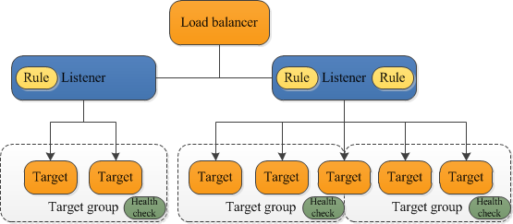

1. Target Group

 It acts as a logical grouping of EC2 instances or IP addresses that the load balancer directs traffic to base on configured routing rules. Essentially, a Target Group defines where traffic should be sent when a load balancer rule is triggered, allowing for flexible routing and load distribution.

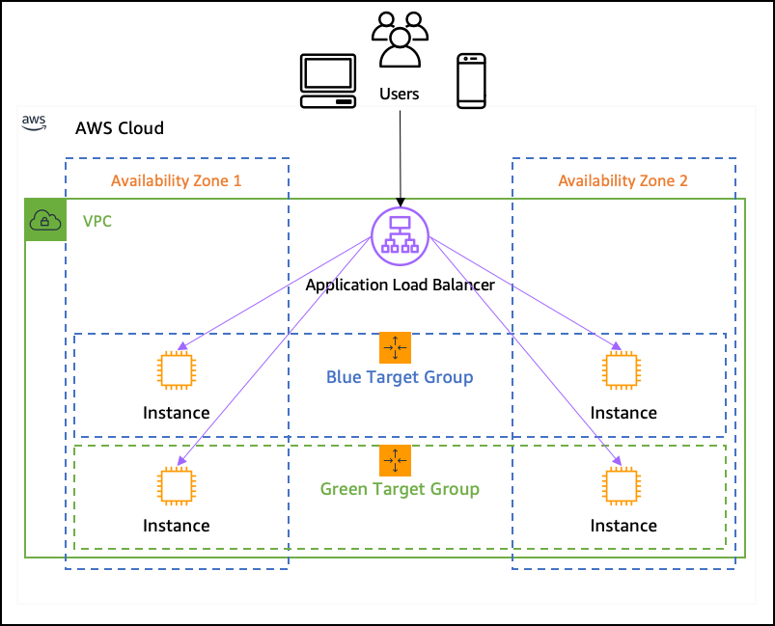

1. Auto Scaling Group

An *Auto Scaling group* contains a collection of EC2 instances that are treated as a logical grouping for the purposes of automatic scaling and management.

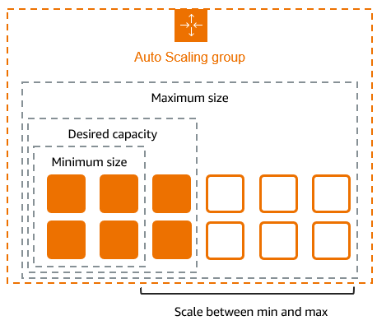

1. Route 53

Amazon Route 53 is a highly available and scalable cloud Domain Name System (DNS) web service which is scalable and high available. It is essential for conversion of user-friendly domain names into IP addresses so that internet communication can proceed without difficulties.

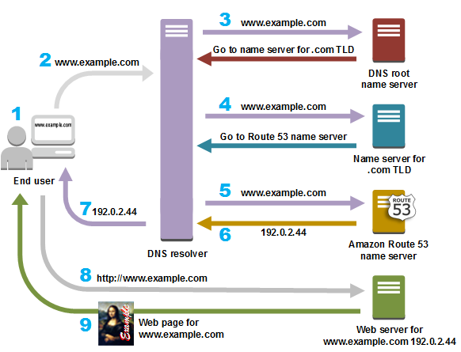

1. CloudFront Distribution

It is a content delivery network (CDN) service provided by Amazon Web Services (AWS). It helps accelerate the distribution of static and dynamic web content to users worldwide by caching content at edge locations, reducing latency and improving performance